Meatless Meal: Garlicky White Bean Stew
Posted by Sarah Britton
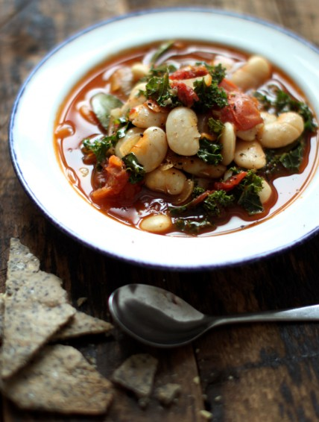
When I was in school for nutrition I went back home to live with my mom. (Understatement of the year to say she was happy about this.) This is when I began really cooking for the first time in my life. Every night was an experiment: knives blazing, spices flying, pots and pans getting some serious exercise. We always sat down to something special and, despite my insanely busy schedule, I found that cooking dinner for us was the most relaxing moment of my day.
Sometime during those months, I came up with this stew. On a particularly busy night when I was cramming for an exam, I threw together what we had in the fridge--amazing how cleaning out the kitchen can result in such deliciousness! This dish quickly became a staple and my mom, although now living without her live-in chef, has mastered it as well.
I am always trying to get more kale into my diet. Why? Because it packs more nutritional punch per calorie than almost any other food on the planet. Seriously. It is chock-full of vitamin K, an essential vitamin for preventing bone fractures, postmenopausal bone loss, calcification of your arteries, and has even been shown to protect against liver and prostate cancer.
Kale is the richest source of carotenoids in the leafy-green vegetable family, making it a top cancer-fighter. Kale helps to regulate estrogen, protects against heart disease, and regulates blood pressure. The calcium in kale is more absorbable by the body than milk (and ounce for ounce, contains more calcium than milk)! This makes it an excellent choice for both prevention and treatment of osteoporosis, arthritis and bone loss.
Garlicky White Bean & Kale Stew
Serves 3-4
Ingredients:
Knob of coconut oil or ghee
2 medium onions
6 cloves garlic
1 teaspoon smoked paprika (optional, but really delicious)
5 bay leaves
Pinch chili flakes
Sea salt
Cracked black pepper
2- 2 ½ cups cooked white beans (lima, butter, navy, cannelini…)
2 cups packed shredded kale leaves
2 cups vegetable broth
1 can (14 oz.) organic whole tomatoes
Cold-pressed olive oil to garnish
Directions:
1. Heat a knob of oil in a large stockpot. Slice onions and add to the pot with a couple pinches sea salt, chili, bay leaves and paprika. Cook for a few minutes until the onions have softened, then add sliced garlic. If the post becomes dry, add a little juice from the tinned tomatoes.
2. Add all other ingredients, bring to a boil, season to taste, and serve with a drizzle of olive oil (since everything is cooked, you don’t need to heat it long). If you are going to let it simmer for a while, add the kale about 5-10 minutes before serving so that it retains more of its nutritional value.
Sarah Britton is a holistic nutritionist, vegetarian chef, and the creator of the award-winning blog My New Roots. Sarah is currently a chef at three organic restaurants in Copenhagen, Denmark, where she has earned praise for her creative and adventurous recipes. A Certified Nutritional Practitioner, she is also the founder of New Roots Holistic Nutrition, where she educates others to be an active participant in their own health and healing.

